**Group Project Log**

***Note:*** *all information must be filled out. You must hand in the project log along with each group project deliverable for this course (e.g., milestones, proposals, reports). The percentage of work allocated to each group member must add up to 100%.*

|  |  |
| --- | --- |
| **Group Name:** | TechGoons |

|  |  |
| --- | --- |
| **Group Members:** | 6 |

|  |  |
| --- | --- |
| **Deliverable:** | Project Proposal |

|  |  |
| --- | --- |
| **Group Member Name** | **Work Done (%)** |
| Dhruv Purohit | 16.67 |
| Gaganpreet Singh | 16.67 |
| Ghazayil Alkhalifah | 16.67 |
| Jeel Gondaliya | 16.67 |
| Mohammed Sohail Ahmed | 16.67 |
| Varun Mahagaokar | 16.67 |

**PROJECT PROPOSAL**

**Blood-Life:**

**An Integrated Blood Management System**

Members and Contributors

|  |  |  |
| --- | --- | --- |
| Dhruv Purohit  B00821734  dhruv.purohit@dal.ca | **Gaganpreet Singh**  B00819217  gaganpreet.singh@dal.ca | **Ghazayil Alkhalifah**  B00559684  ghazayil.alkhalifah@dal.ca |
| Jeel Gondaliya  B00819827  jl251073@dal.ca | **Md. Sohail Ahmed**  B00821054  sh488044@dal.ca | **Varun Mahagaokar**  B00826634  vr616271@dal.ca |

Faculty of Computer Science  
Dalhousie University

July 31st, 2019

# ABSTRACT

**[6] The blood forms about 7% of the human body, it consists of many components e.g. red blood cells, white blood cells, plasma and platelets. Until this day; science fails to produce blood in laboratories, the only source of blood is through donation. In this paper we introduce ‘Blood Life’, a web portal, which provides a common platform to improve medical emergency response by streamlining supply chain management, aligning blood collections with demand and managing blood bank pool. The purpose of this portal is to address the lack of platforms that provides a consistent connection between receivers, donors and blood bank organizations (BBO).**

# KEYWORDS

**Blood, Blood Collection, Blood Management System, Blood Organization, Blood Group, Donor, Donation, Receivers.**

**CONTENTS**

ABSTRACT ii

KEYWORDS ii

1. Introduction 1

1.1 Live Project URL 1

2. Background 2

2.1 Competitive Landscape 2

2.2 Problem and Approach[7][8] 2

3. APPLICATION DETAILS 3

3.1 Target User Insight 3

3.2 User-Centered Design Approach 3

3.2.1 Information Architecture 3

3.2.1.1 User Personas [7] 3

3.2.1.2 Intended Scenarios and Use Cases [7] 4

3.2.1.3 Use Case Diagram [7] 8

3.2.1.4 Site Mapping [7] 9

3.2.1.5 User Experience and Task Flow Diagrams [7] 10

3.3 Design and Layout 13

3.3.1 Wireframes 13

3.3.2 Screenshots of BloodLife 28

3.3.3 INVENTORY 35

4. Application Workflow 36

4.1 Interaction design 36

4.1.1 Click Streams 36

4.2 Process and Service Workflow 43

4.2.1 Workflow of The Application 43

4.2.2 Technology Used 44

4.2.3 File and Folder Structure 44

5. GROUP ROLES 45

6. REFERENCES 46

# Introduction

Throughout the world, there is a widening variance in the supply and demand for

blood and this gap is increasing day by day. [1]A study in U.S. has shown that supply of

non-available blood group units to the closest blood bank can take up to 7 days. However, we lack a platform that can bridge this gap and enhance the information

sharing among different facilities regarding the availability of different blood group units.

‘BloodLife’, a web portal, will provide a common platform to improve medical emergency response by streamlining supply chain management, aligning blood collections with demand and managing blood bank pool.

## Live Project URL

The website can be accessed by visiting the given URL:

[**https://group14bloodlife.herokuapp.com/index**](https://group14bloodlife.herokuapp.com/index)

The code for these webpages can be access through [GitLab](https://git.cs.dal.ca/mahagaokar/Group14_TechGoons).

# Background

## Competitive Landscape

The overall design, usability and communication with users of the web service ‘BloodLife’ has been compared with Canada Blood Services web portal. The Canada Blood service consists of highly informative layout which directs a person how to donate blood. However, the web service is unable to navigate user to post a request for the blood. ‘BloodLife’ helps the user in such a way that a user can easily request for blood without logging in. There is too much information for a user to read on a single page which might confuse a person. Too much textual information might bother a user.

BloodLife consists of balanced design which displays information that might lead a user to complete one’s task.

## Problem and Approach[7][8]

The purpose of this project is to address the lack of platforms that provides a consistent connection between receivers, donors and blood bank organizations (BBO). The goal is to make this platform available to the public to be able to check availability of blood groups in the different organizations available on the platform or connect to donors if there was a deficiency in a demanding blood group. This platform holds many important features to achieve our purposed goal.

# APPLICATION DETAILS

## Target User Insight

This web portal targets people who are willing to donate blood. Also, people who need blood have a single point of access. All they must do is perform a search for the required blood group, and all the blood banks near that user will be checked and results will be displayed with the nearest center being displayed at the top. [7]

## User-Centered Design Approach

### Information Architecture

This section presents the complete architecture of the web application. The sub-sections cover the user personas, use case scenarios, use case diagrams, sitemap and wireframes to better understand the working of ‘BloodLife’ web application.

### User Personas ****[7]****

**The following personas have been defined for ‘BloodLife’:**

|  |  |
| --- | --- |
| **Personas** | **Description** |
| ***Blood Bank Organization*** | **Different organizations need to maintain records of various blood group units available at site, historical records of blood given to a seeker or blood collected from a donor etc.** |
| ***Donors*** | **Any person who is registered with BloodLife and is willing to donate blood.** |
| ***Receivers*** | **Any person who may or may not be registered with BloodLife but needs blood.** |

Table 1) Personas of BloodLife

### Intended Scenarios and Use Cases ****[7]****

The following scenarios have been identified for BloodLife:

|  |
| --- |
| **Scenario #1** |
| ***Use Case*** | Manage Blood Bank Pool | |
| ***Primary Actor*** | Blood Bank Organisation | |
| **Stake Holder & Interests** | | |
| ***User*** | Wants to manage blood bank pool, download reports etc. | |
| ***Preconditions*** | The organisation is registered with BloodLife | |
| ***Postconditions*** | All the activities performed by the users are recorded and saved into the database. | |
| **Main Success Scenario** | | **Alternative Flow** |
| 1. The organisation user logs in to the web portal.    1. In case the blood is given to a seeker, the stock details will be updated accordingly. Also, the seeker must fill out the necessary documentations and personal details are entered in the database.    2. When a donor donates blood, Database needs to be updated.    3. The user can fetch weekly, monthly or quarterly reports through dashboard.    4. The user can also add updates on events that may happen in the organisation. | | 1. Login Failure   In case the user cannot remember the password or username, super user needs to be informed and then password can be reset.   1. Organisation is not registered   The Organisation may not be registered with BloodLife   1. Register the organisation with BloodLife. |

**Table 2) Use Case- Manage Blood Bank Pool**

|  |
| --- |
| **Scenario #2** |
| ***Use Case*** | Register as a donor | |
| ***Primary Actor*** | Donor | |
| ***Prerequisite*** | The donor has a valid email account | |
| **Stake Holder & Interests** | | |
| ***User*** | Wants to register himself as donor with BloodLife | |
| ***Preconditions*** | Must have a valid email address. | |
| ***Postconditions*** | The user should receive an email once successfully registered.  Also, the Database must be updated on completing registration. | |
| **Main Success Scenario** | | **Alternative Flow** |
| 1. The user attempts to register himself as a donor on BloodLife. 2. A confirmation email is sent to donor. 3. In case of need of a specific blood group type, the web portal will automatically identify and notify these donors. | | 1. Registration Failure 2. The user is displayed with appropriate error message. 3. Assist user in filling up the registration form by providing description for each field. 4. Retry registration. |

**Table 3) Use Case- Register as a donor**

|  |
| --- |
| **Scenario #3** |
| ***Use Case*** | Refer friends as a donor | |
| ***Primary Actor*** | Donor | |
| **Stake Holder & Interests** | | |
| ***User*** | Wants to manage personal profile and refer a friend to BloodLife | |
| ***Preconditions*** | The user is registered with BloodLife | |
| ***Postconditions*** | Any changes made by user in the personal profile are updated in Database and email must be sent to all the friends referred by this user. | |
| **Main Success Scenario** | | **Alternative Flow** |
| 1. The donor logs into personal account. 2. The user provides the email address of a friend to register them to BloodLife. 3. An email notification is sent to these people with a link to the registration form. | | 1. Unable to login 2. Click on forgot password button to receive an email on registered email address with detailed instructions 3. Invalid Email Address in provided 4. An appropriate error message is displayed to the user. 5. Allow user to re-enter the email address of the friend. |

**Table 4) Use Case- Refer friends as a donor**

|  |
| --- |
| **Scenario #4** |
| ***Use Case*** | Search for a Specific Blood Group Type | |
| ***Primary Actor*** | Seeker | |
| **Stake Holder & Interests** | | |
| ***User*** | Wants to know which blood bank organisation has the desired blood group. | |
| ***Preconditions*** | None | |
| ***Postconditions*** | Details of the nearest organisation having the required blood group is provided to the seeker. | |
| **Main Success Scenario** | | **Alternative Flow** |
| 1. The user searches for a specific blood type. 2. The web portal provides with list of nearest blood bank organisation that have that blood type. 3. The seeker can now check the location of this organisation and collect blood by going there. 4. The organisation will hand over the blood to the seeker after necessary documentation. | | 1. Specified blood group is not available. 2. In case the blood type is not available, the donors for that blood group are notified immediately. 3. The seeker information is taken through BloodLife. 4. Also, once a donor is available, he is invited to a nearest organisation location and the details are shared with seeker as well. |

**Table 5) Use Case- Search for a Specific Blood Group Type**

### Use Case Diagram ****[7]****

**The Use Case Diagram for BloodLife has been shown in the figure 1.**

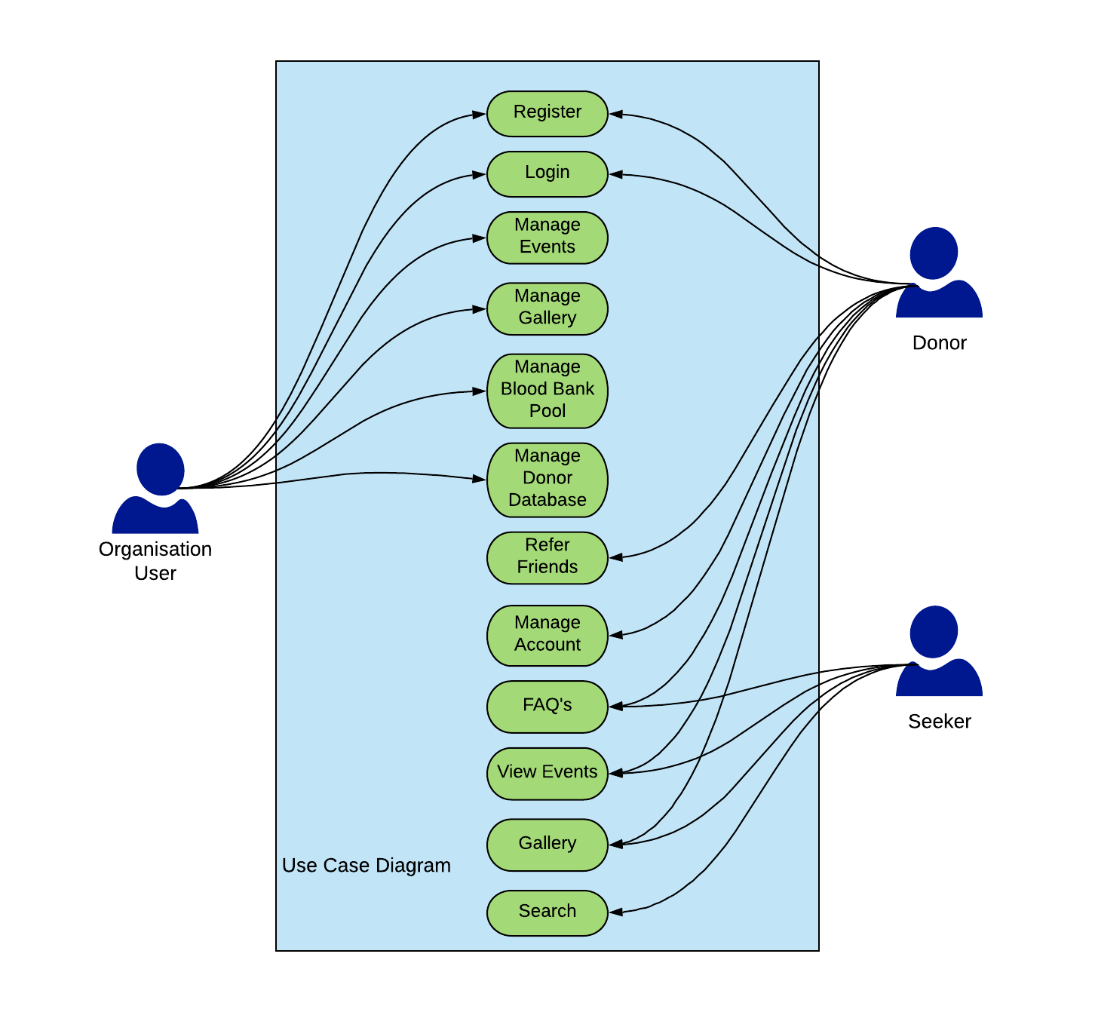

Figure 1) Use Case for BloodLife [2]

### Site Mapping [7]

The Sitemap for ‘Blood Life: An Integrated Blood Management Service’ web application has been shown in figure 2. The website will have a persistent header and footer that will be visible on all web pages. Also, once the user logs-in to the web page, the login button changes to logout and Registration button changes to My Account.

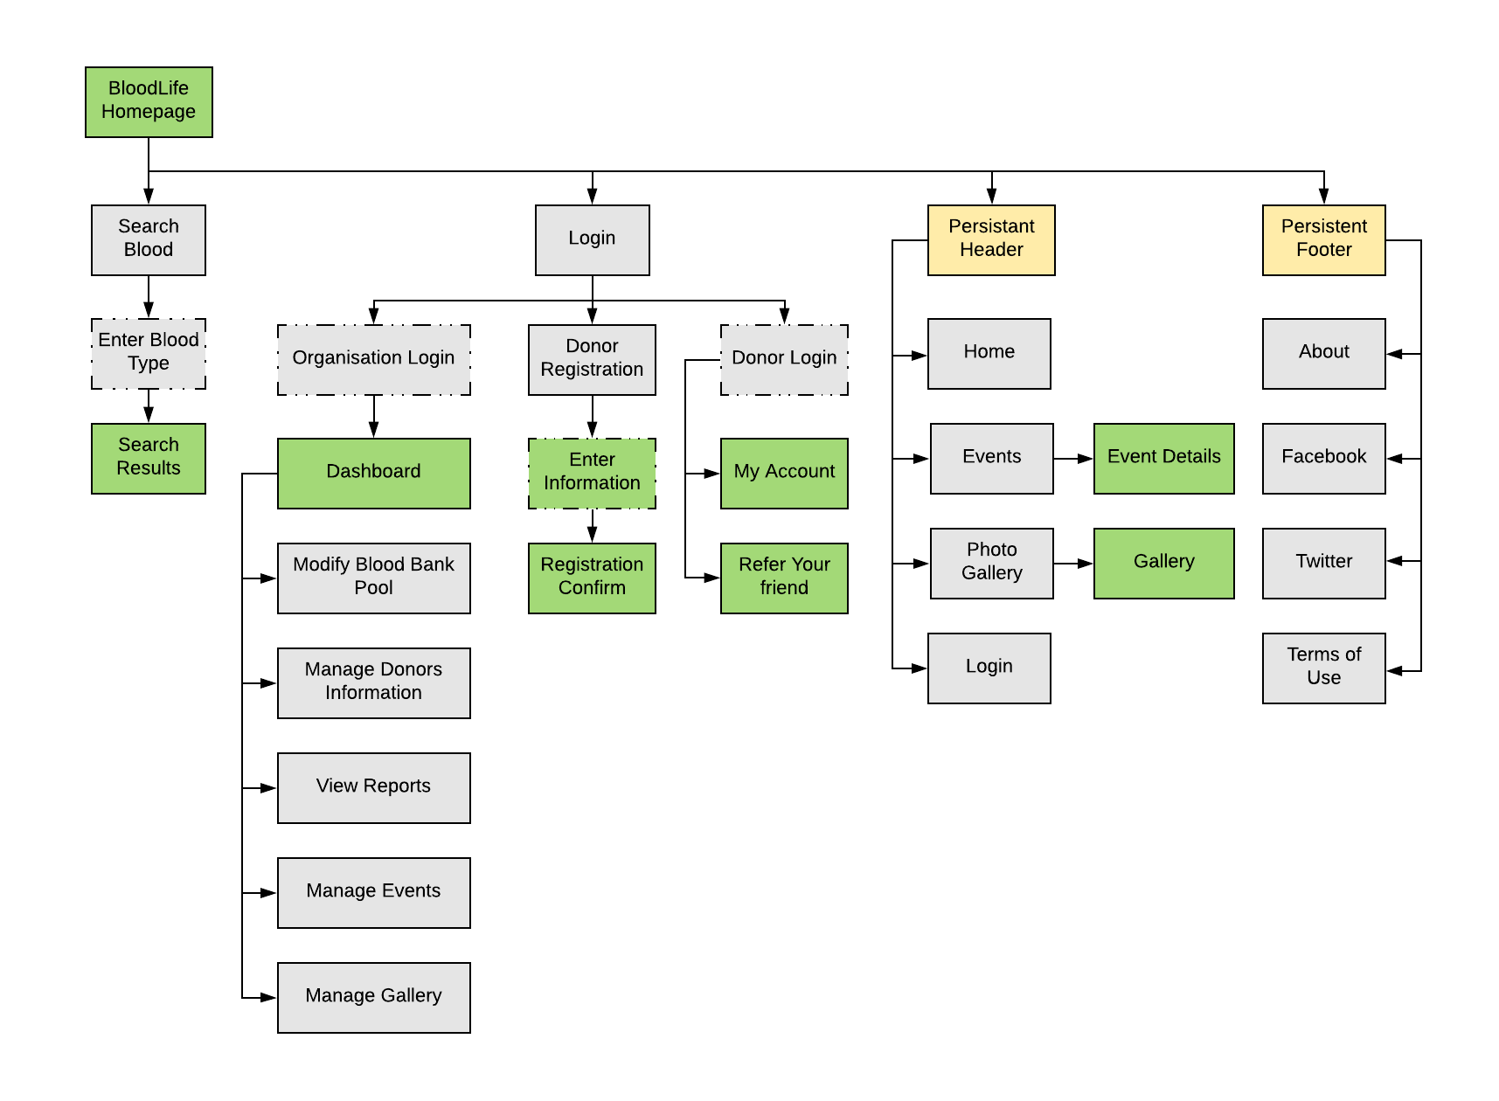

Figure 2) Site Map for BloodLife [2]

### User Experience and Task Flow Diagrams ****[7]****

1. **The seeker searches for the needed blood group on BloodLife. The task flow diagrams shown in figure 3 illustrates this.**

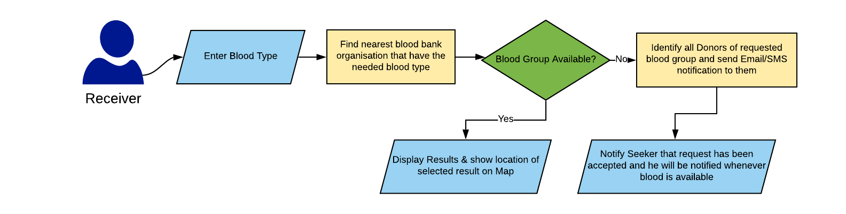

Figure 3) Searching for blood [2]

1. **The user wants to register himself as a donor at BloodLife. The task flow diagram is shown in figure 4.**

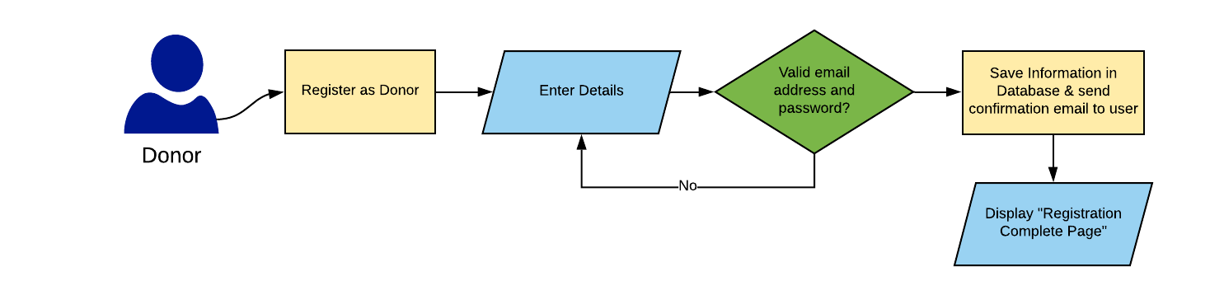

Figure 4) Registering as Donor [2]

1. **Task flow diagram in figure 5 shows the donor trying to log in to BloodLife. He can manage personal account.**

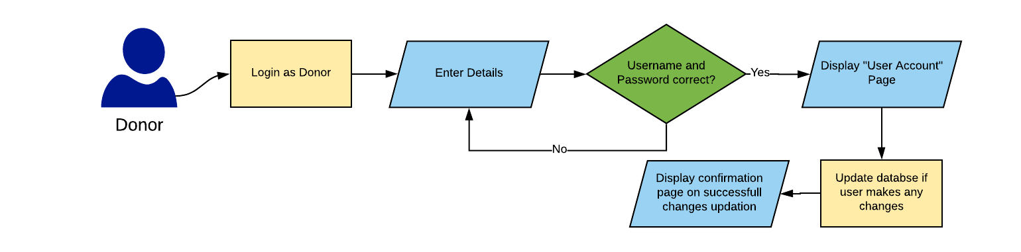

Figure 5) Login as Donor and Manage Account [2]

1. **The figure 6 shows the task flow diagram if a donor forgets a password.**

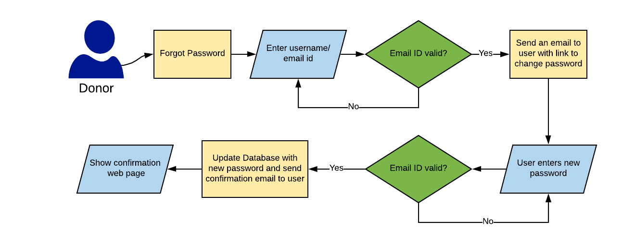

Figure 6) Donor forgot password and procedure to reset it [2].

1. **Task flow diagram for referring someone to BloodLife is shown in figure 7.**

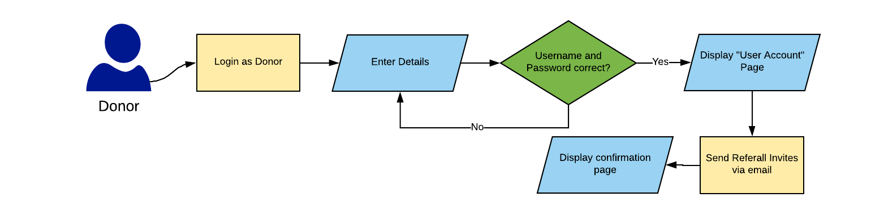

Figure 7) Referring a friend to join BloodLife as a Donor [2]

1. **Figure 8 shows how a user can search for answers to questions. In case, he still has doubts he can raise a ticket on BloodLife**

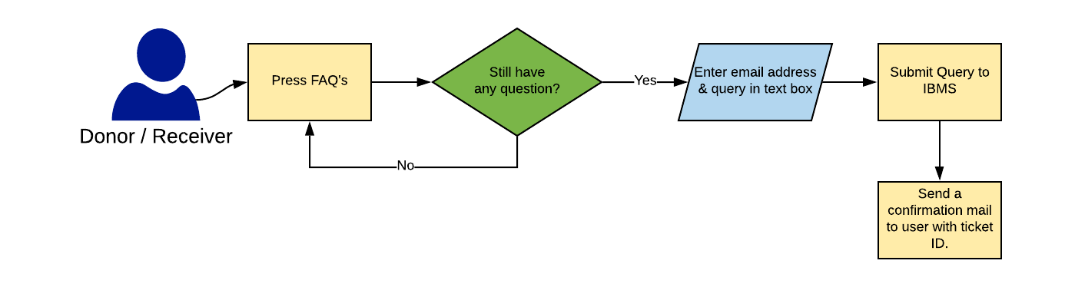

Figure 8) Raising a ticket at BloodLife to enquire anything [2]

1. **Task flow diagram depicting how an organization manages blood bank pool, Donor Database is shown in figure 9.**

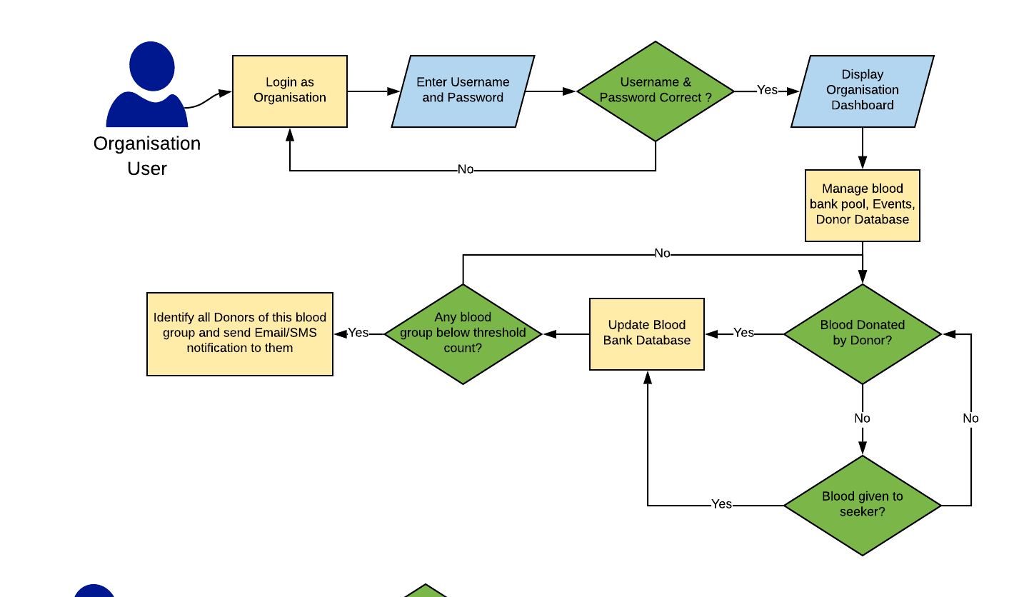

Figure 9) Organization user manages the blood bank pool and Donor Database [2]

1. **Management of events and photo gallery is shown in figure 10.**

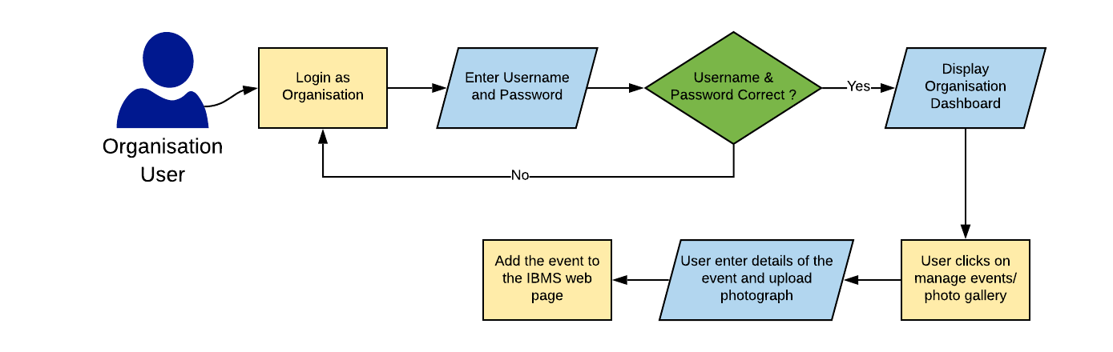

Figure 10) Adding new or modifying existing events on BloodLife [2]

## Design and Layout

### ****Wireframes****

**The Figure 11 shows the wireframe of the landing page for BloodLife. The web page allows the seekers to directly search for blood without any need to log in to the website. Also, the donors and the organization can log in to their respective accounts by signing in.**

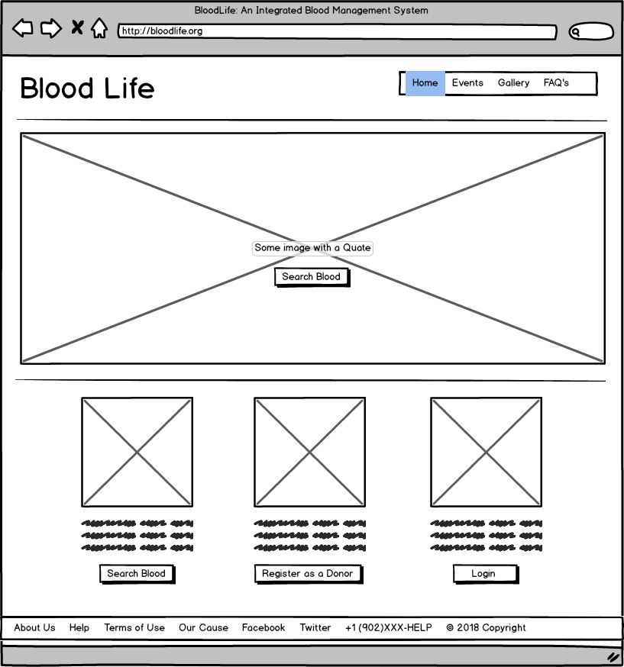

Figure 11) Landing page of BloodLife [3]

**Figure 12 shows how a user can search for blood through BloodLife platform. The user can either look up the Blood Bank Organizations (shown in figure 13) or can submit the blood request by entering blood group type and quantity (shown in figure 14)**

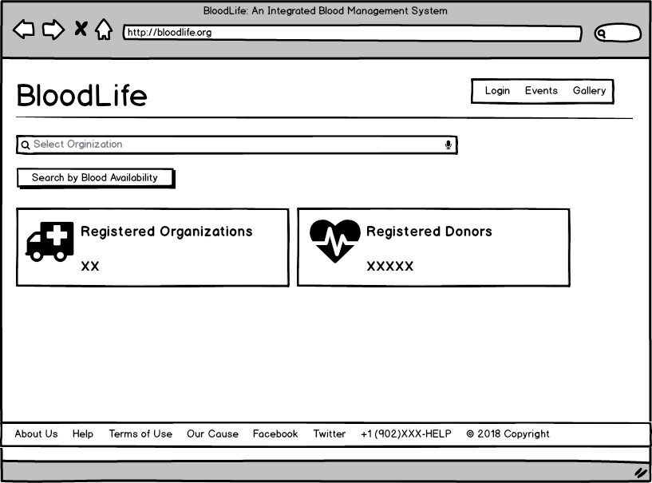

Figure 12) Searching Blood Group on BloodLife [3]

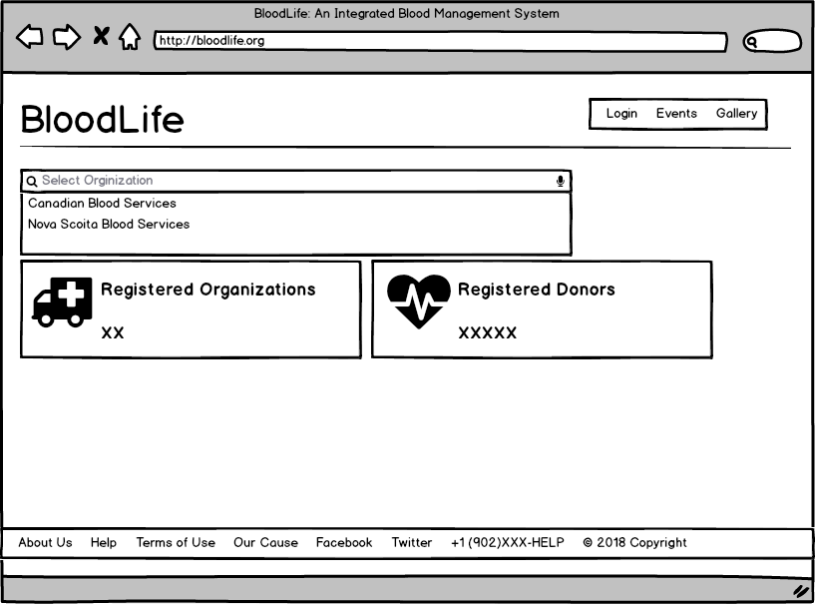

Figure 13) Search blood bank organizations [3]

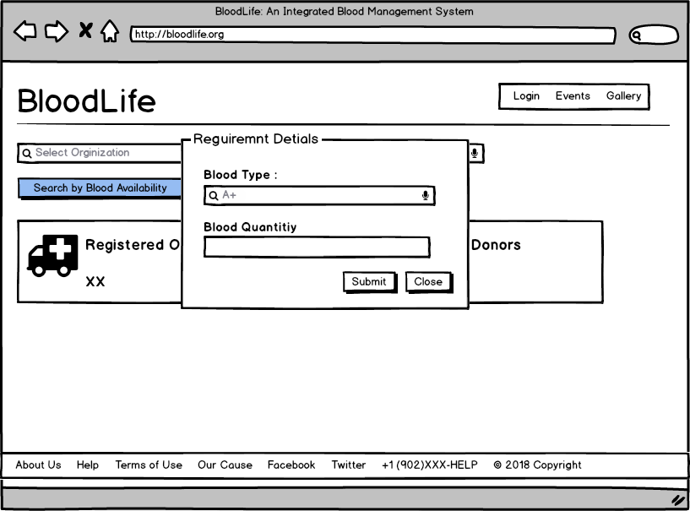

Figure 14) Search blood by blood group type [3]

**Figure 15 shows the results of the search performed by the seeker. On hovering the mouse of over a specific result, the web page will display the location of the blood bank on a map, so that a user can navigate to the blood bank without any difficulties.**

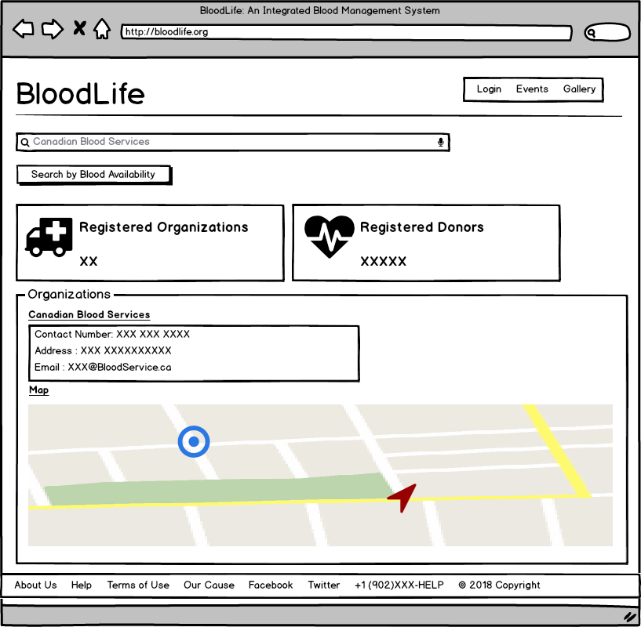

Figure 15) Search results on BloodLife [3]

**Figure 16 shows the registration form for a donor.**

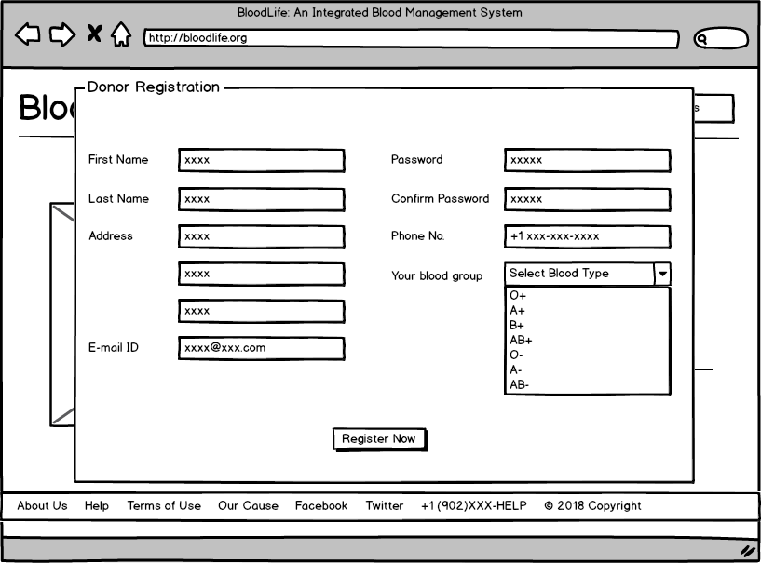

Figure 16) BloodLife donor registration webpage [3]

**The donor and Organization can log in to the website by entering the credentials as shown in figure 17. The user from an organization can enter the credentials and log-in to the web portal on behalf of the organization.**

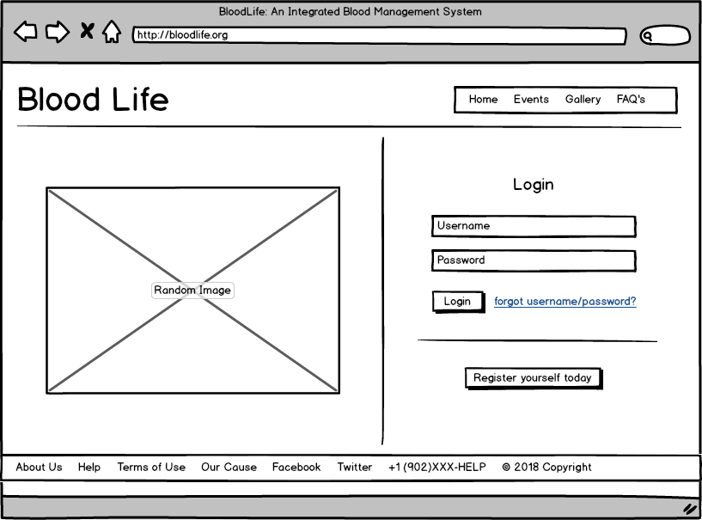

Figure 17) BloodLife Login webpage [3]

**Once, the donor has logged in to the web-portal he can manage personal account details. Also, the donor has an option to refer friends to be a part of BloodLife and register themselves as donors. This has been depicted in figure 18.**

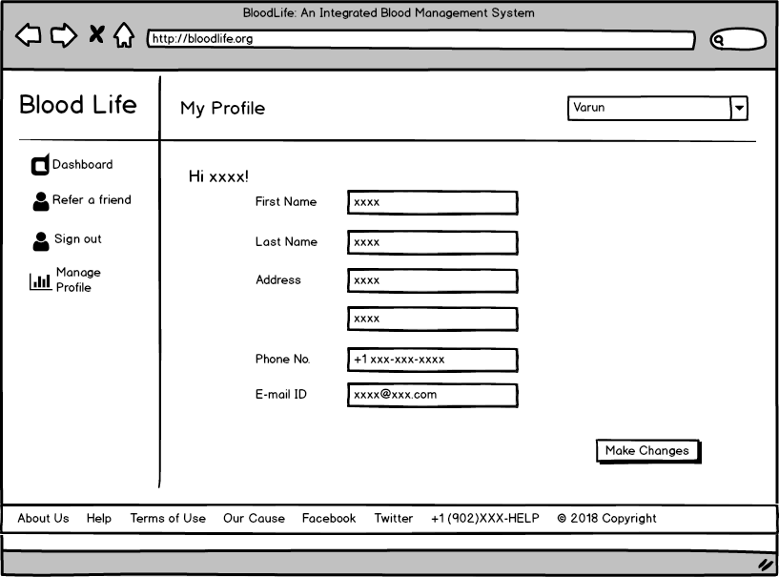

Figure 18) Donor Dashboard in BloodLife [3]

**On successful sign-in the organization user can manage the blood bank pool, donor database and has access to blood bank donation history as well. Also, reports can be downloaded on weekly, monthly, quarterly or yearly basis.**

**The user can also manage events and photo gallery from the Organization dashboard.**

**Figure 19, 20 & 21 illustrates the same.**

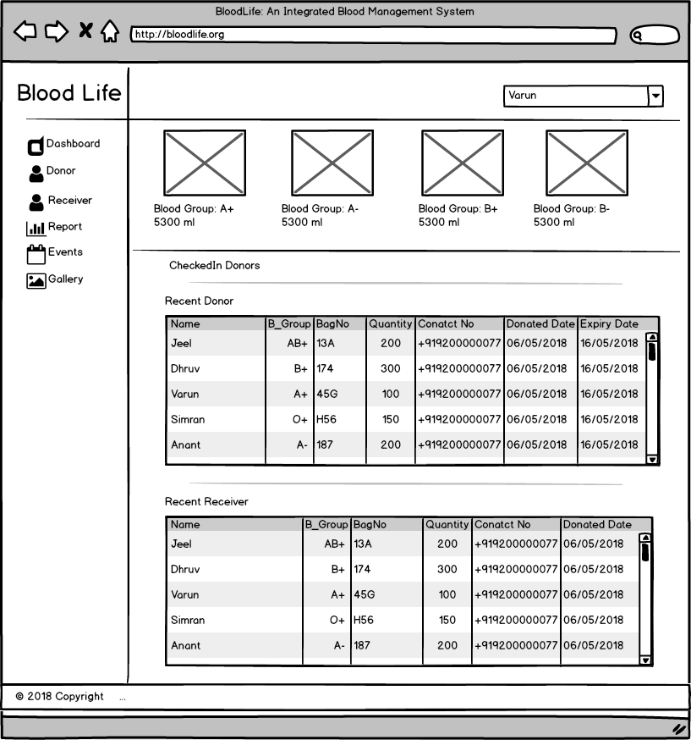

Figure 19) Organisation Dashboard [3]

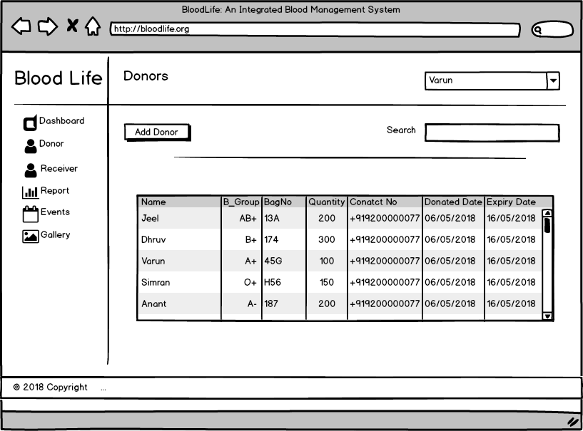

Figure 20) Organization Donor’s Dashboard [3]

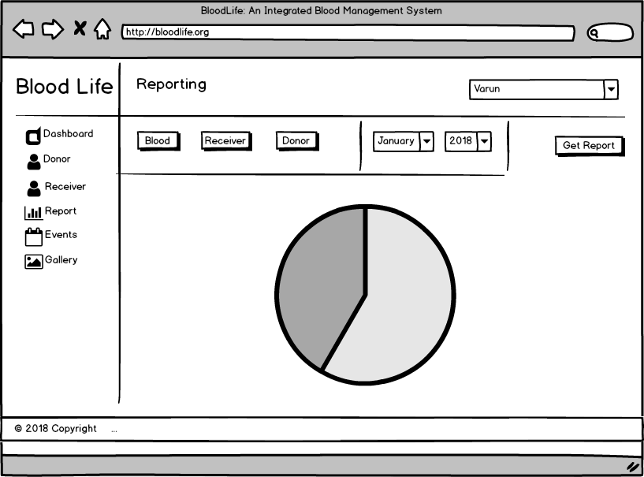

Figure 21) Organization view reports [3]

A user can see the events happening around him by going to the events section. The figure 22 shows the event section on BloodLife.

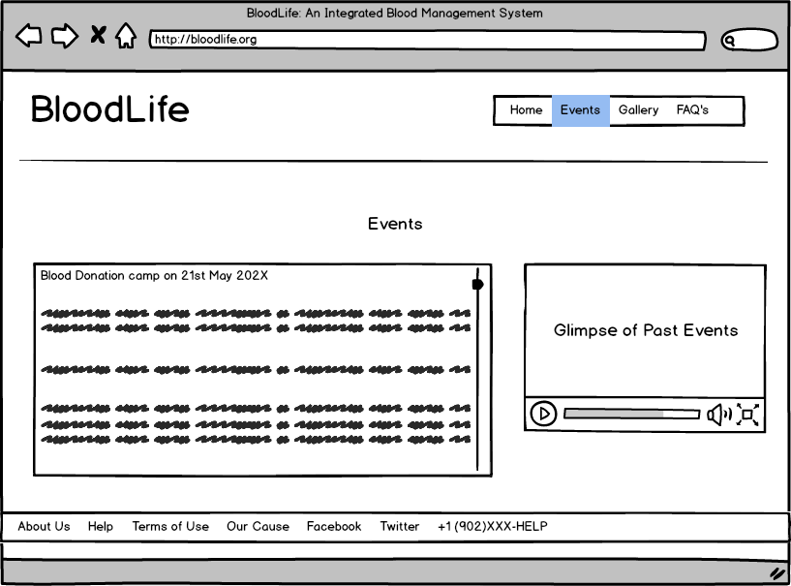

Figure 22) Events Section [3]

**Figure 23 shows the photo gallery for each organization.**

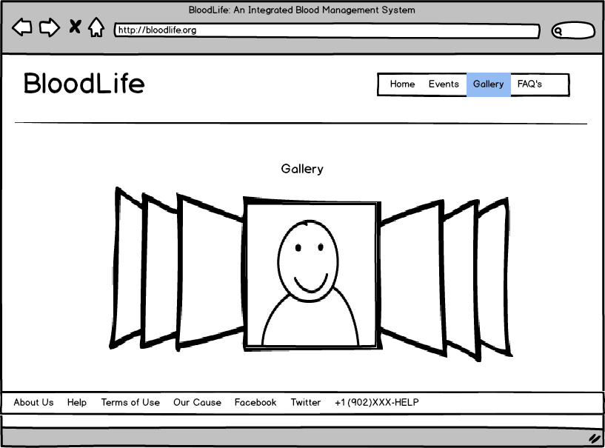

Figure 23) Photo Gallery [3]

**The webpage will also have a Frequently Asked Questions where a user can search answers to some common questions. In case the user still has some unanswered questions, he can ask questions over email. The same has been illustrated in the figure 24.**

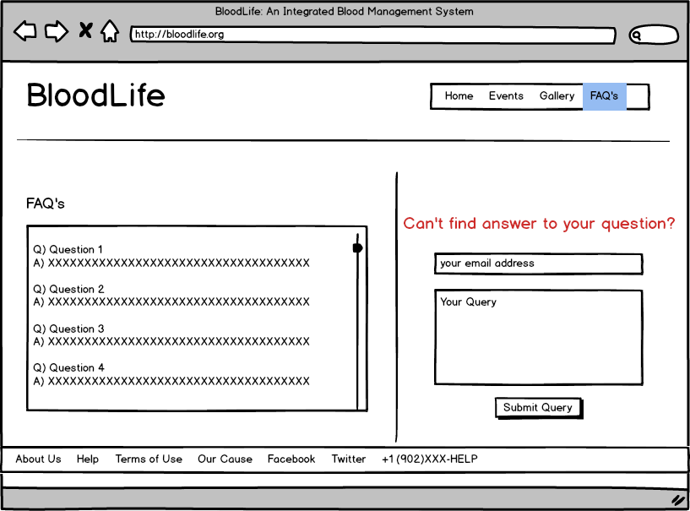

Figure 24) FAQ’s Section in BloodLife [3]

**The webpages shown in figure 25 explains on why someone should donate blood.**

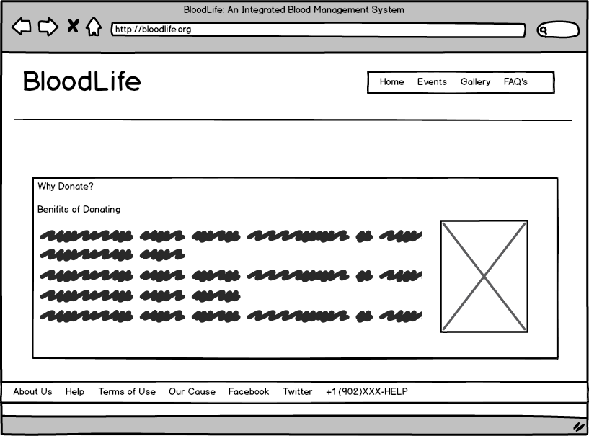

Figure 25) Benefits of donating blood. [3]

### ****Screenshots of BloodLife****

Figure 26-34 show few of the screenshots of the web application. The website is still under development phase and design changes may be made as we progress.

**Figure 26 is the landing page of website which shows how a user can search for blood bank organization through BloodLife platform.**

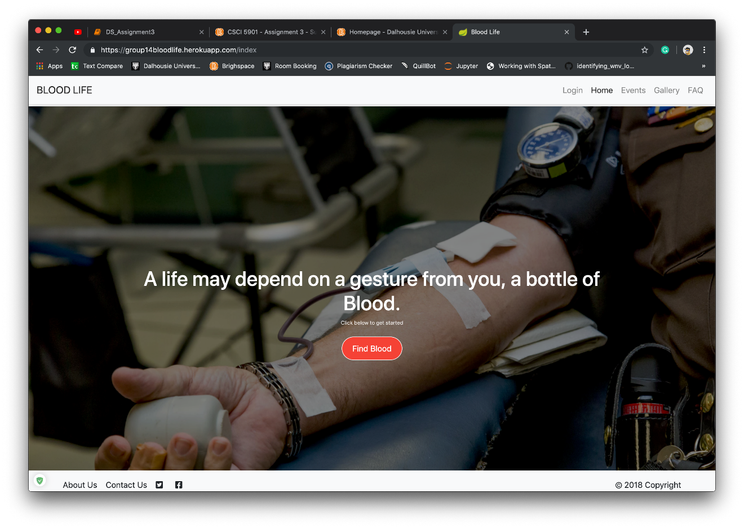

Figure 26) Landing page of BloodLife.

Figure 27) Search Results for blood request.

**Figure 27 shows the results of the search performed by the user and it displays the location of the organization.**

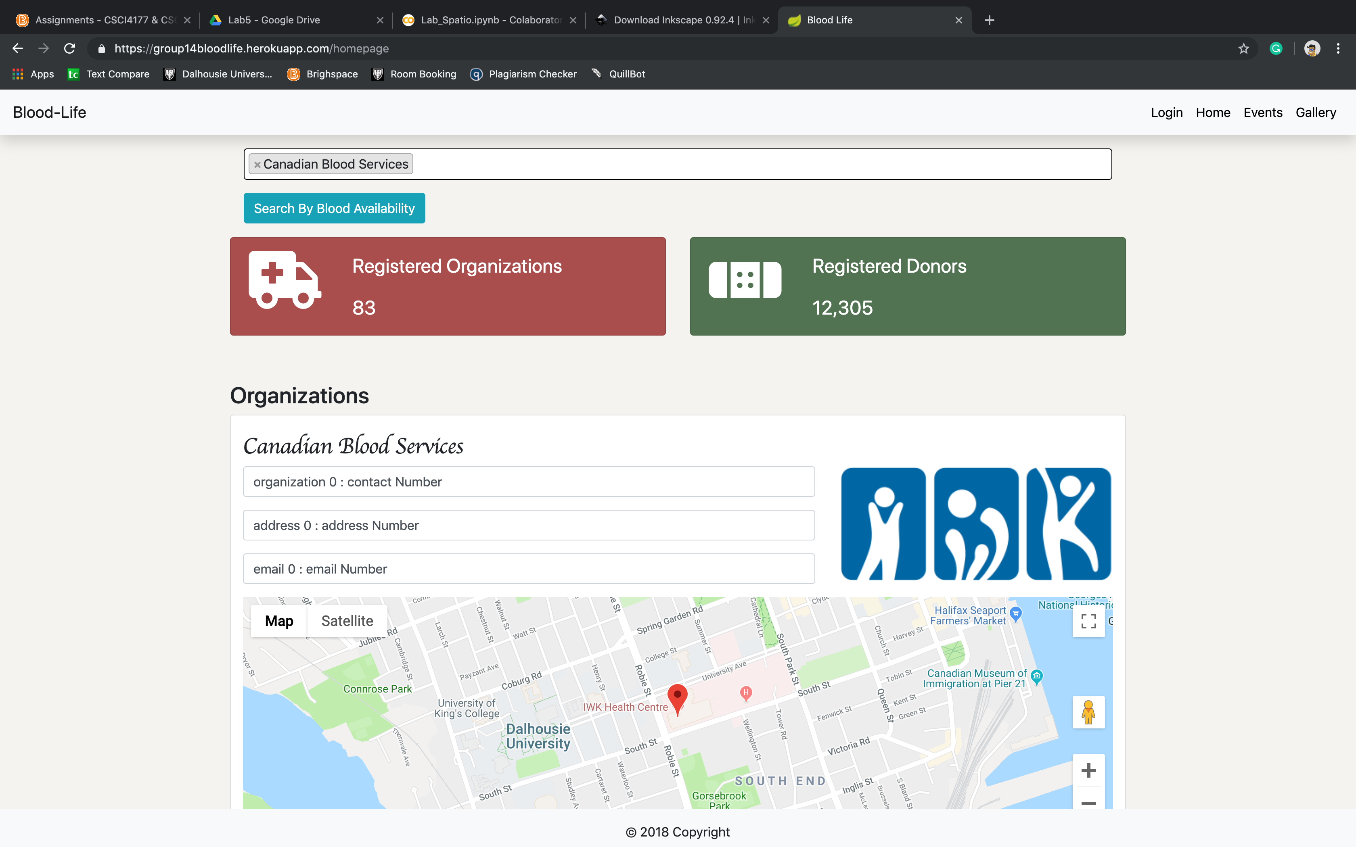

Figure 27) Search Organization

Figure 28 shows the gallery management page of the website.

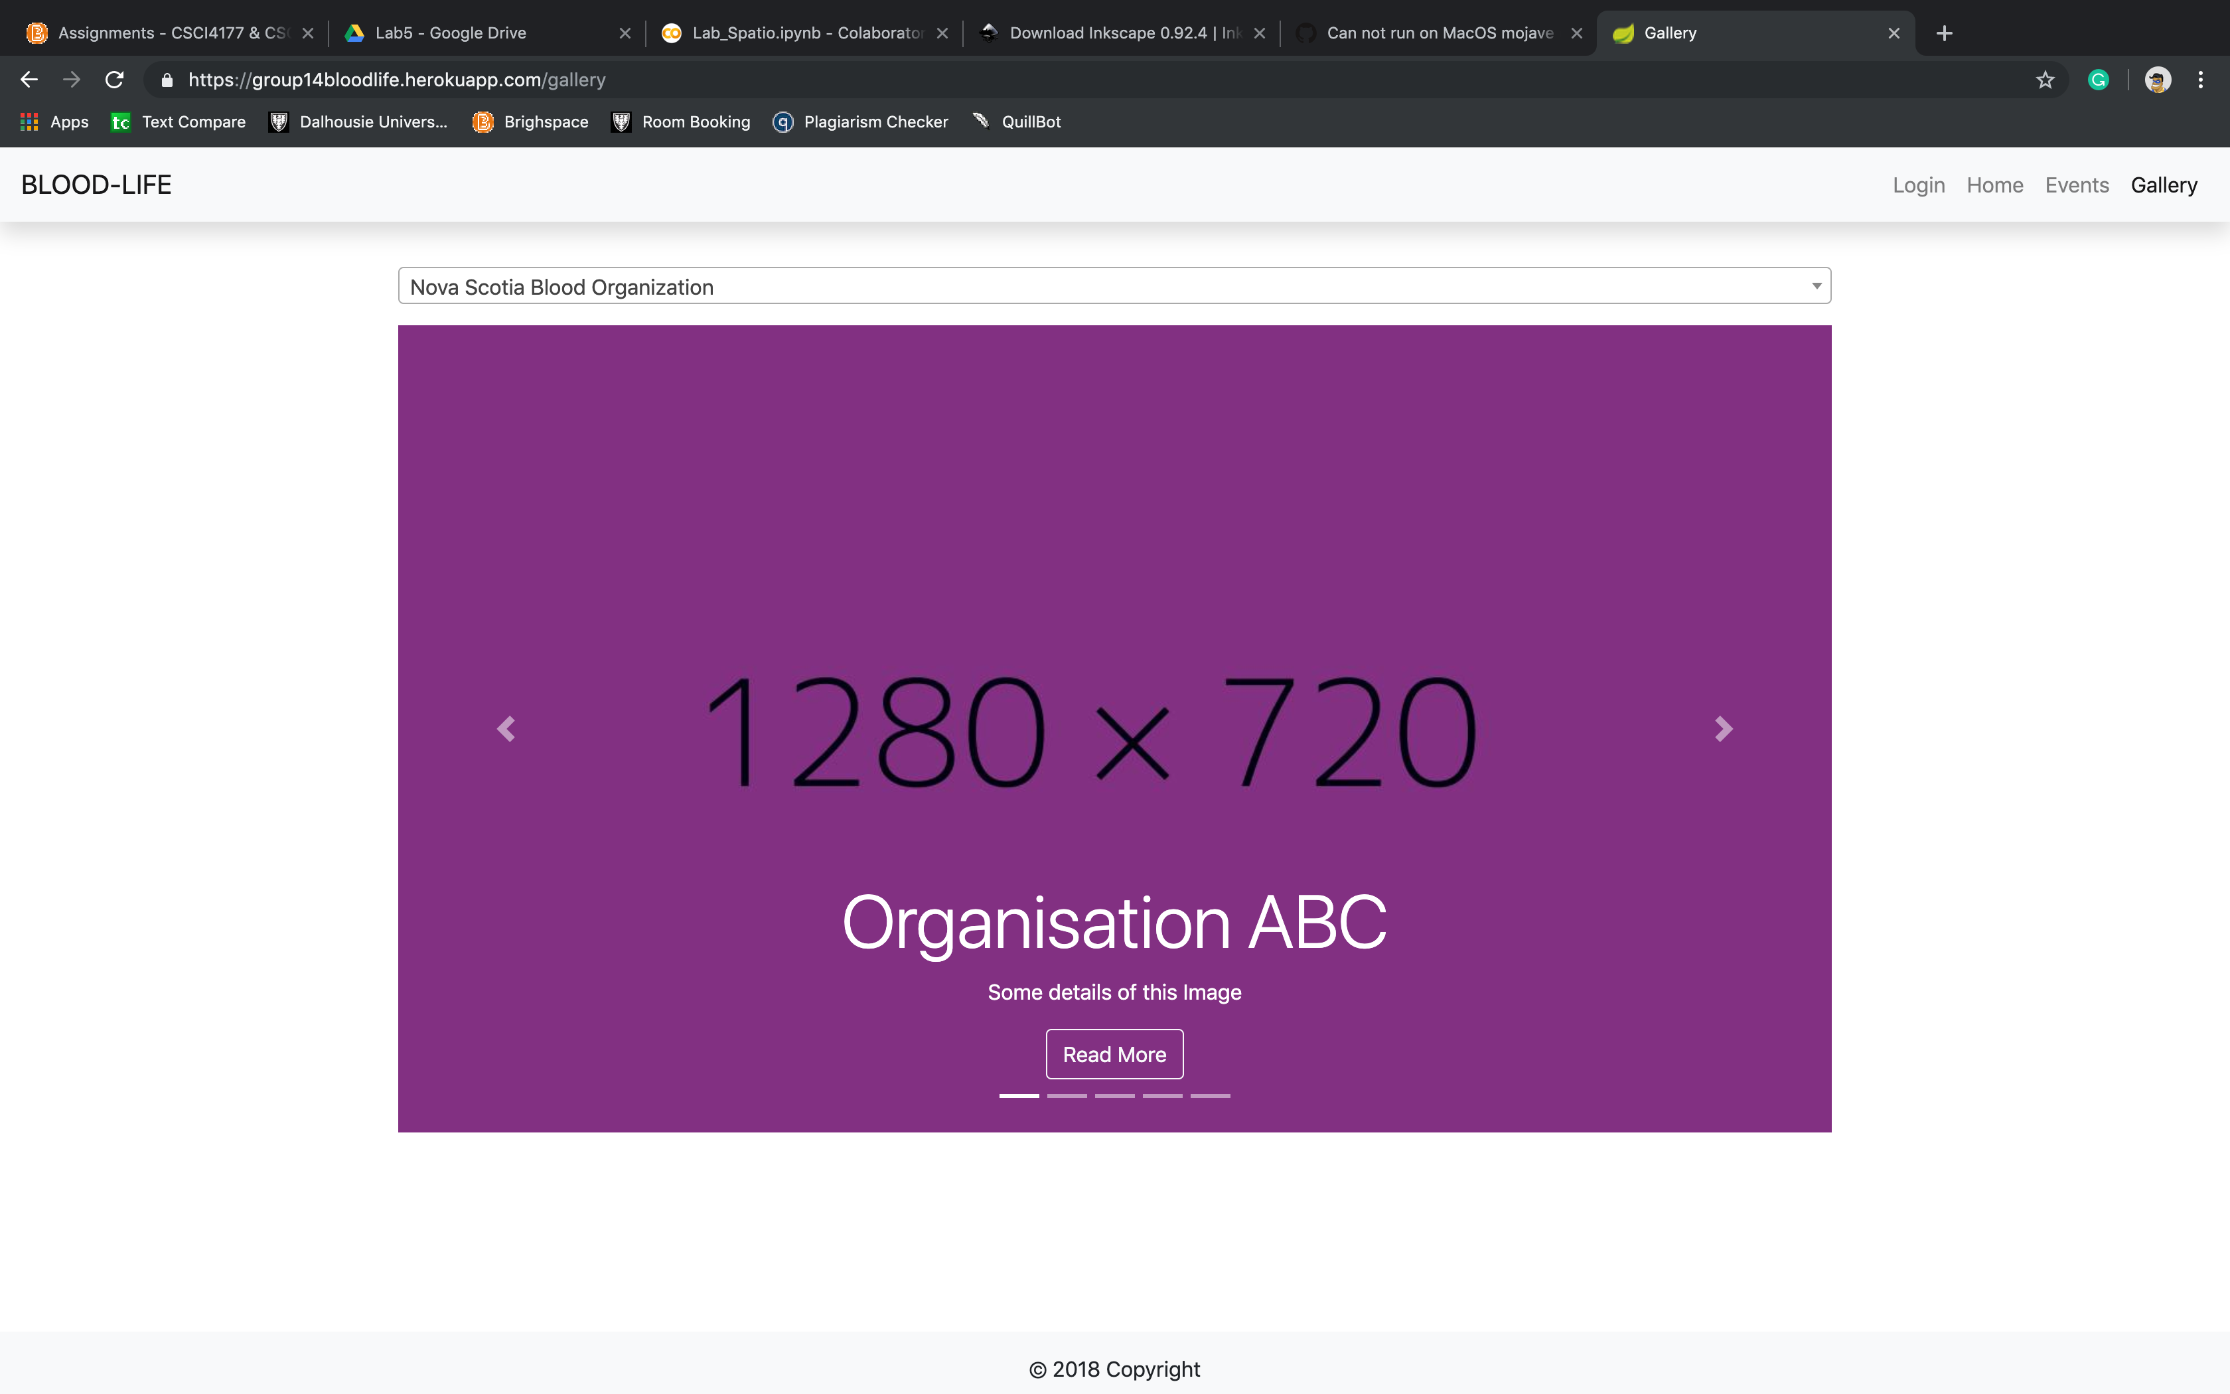

Figure 28) Gallery page of BloodLife

Figure 29 shows the ‘Events’ Page of the website, where the list of all the events are displayed.

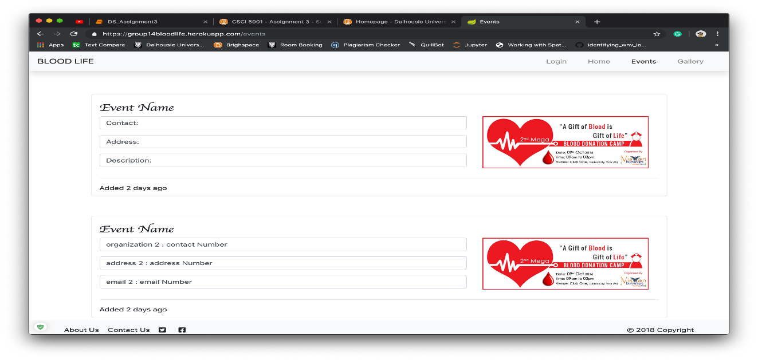

Figure 29) Events Page.

Figure 30 shows the login page of the website, where user can login to the website or even register for the website.

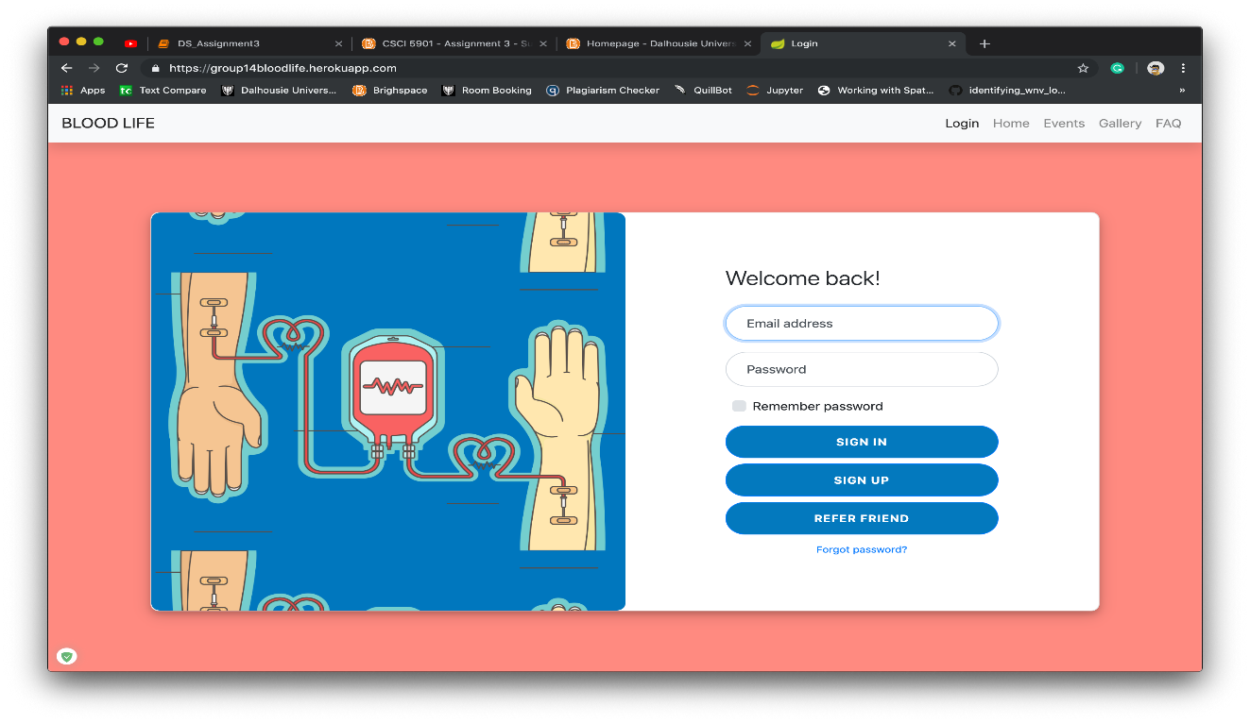

Figure 30) Login Page for BloodLife

Figure 31 displays the dashboard of the organization.

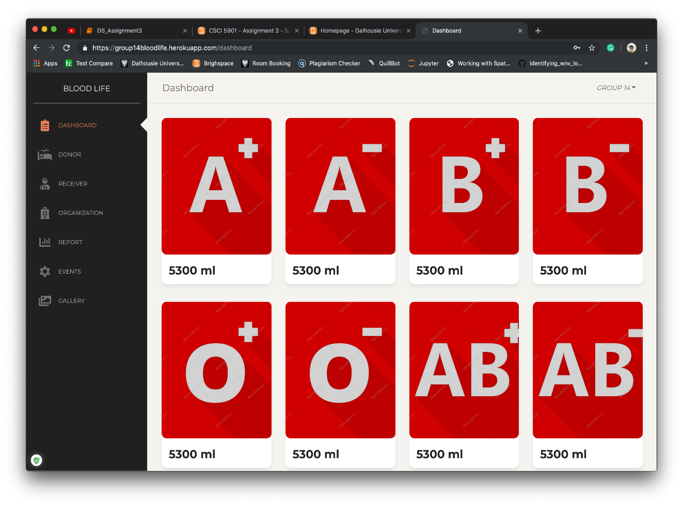

Figure 31) Organization Dashboard

Figure 32-33 show the donor and receiver details of each organization.

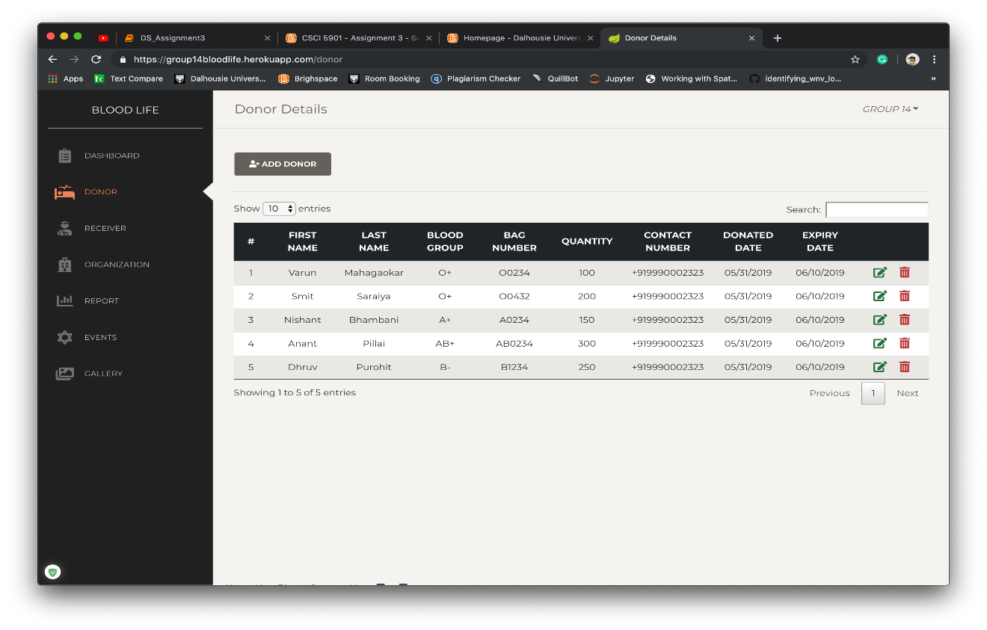**Figure 32) Donor Details**

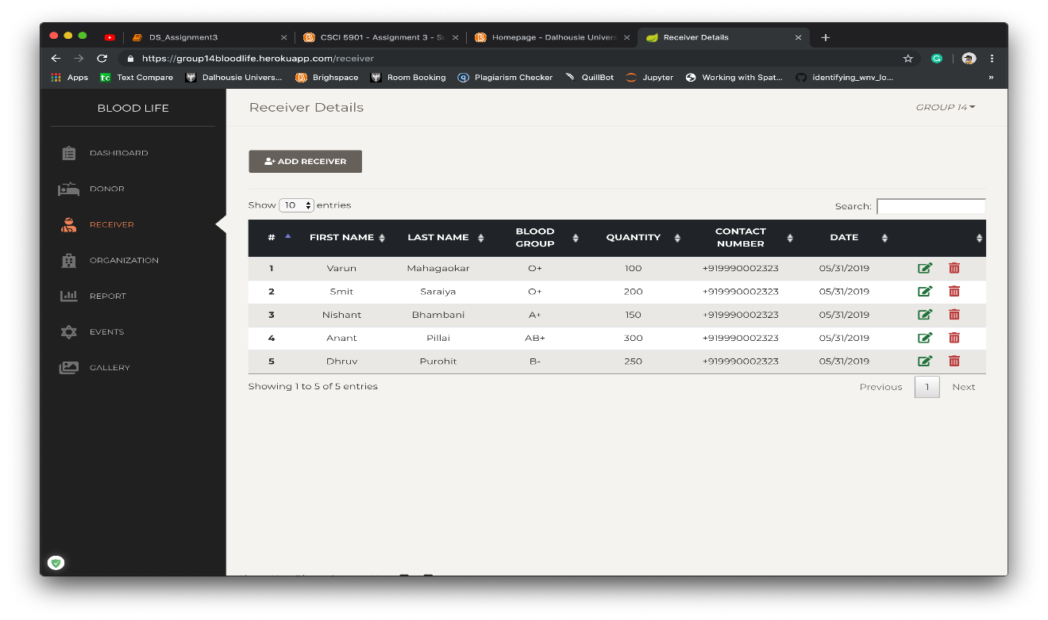

Figure 33) Receiver Details

Figure 34 shows the list of events, which are posted by the organization.

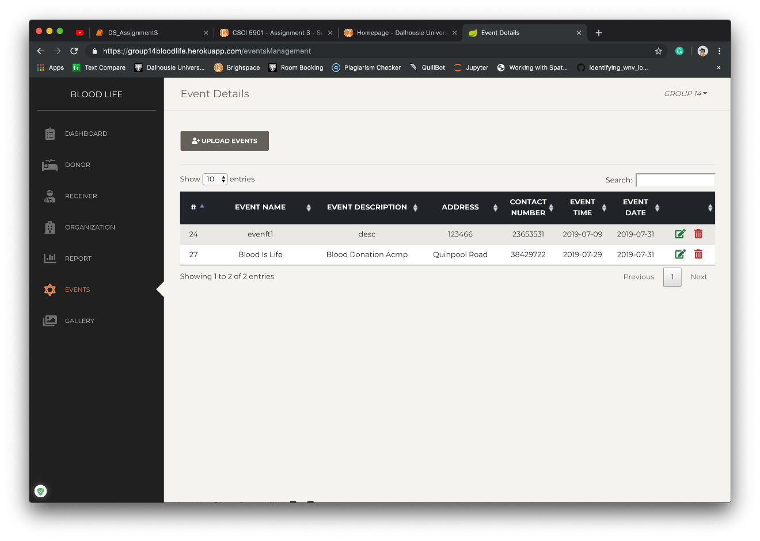

Figure 34) Event Management

Figure 35-36 show the visualization charts for organization.

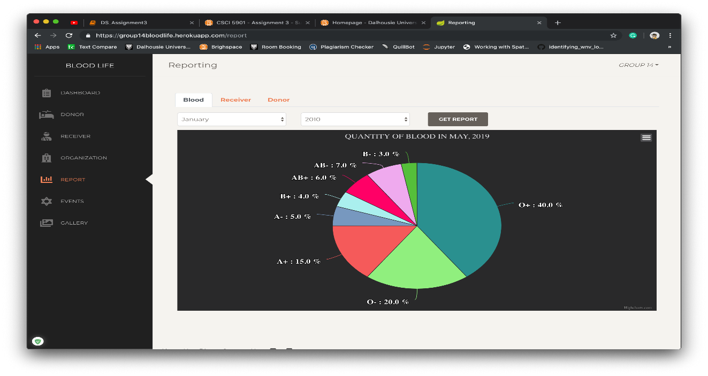

Figure 35) Organization Report

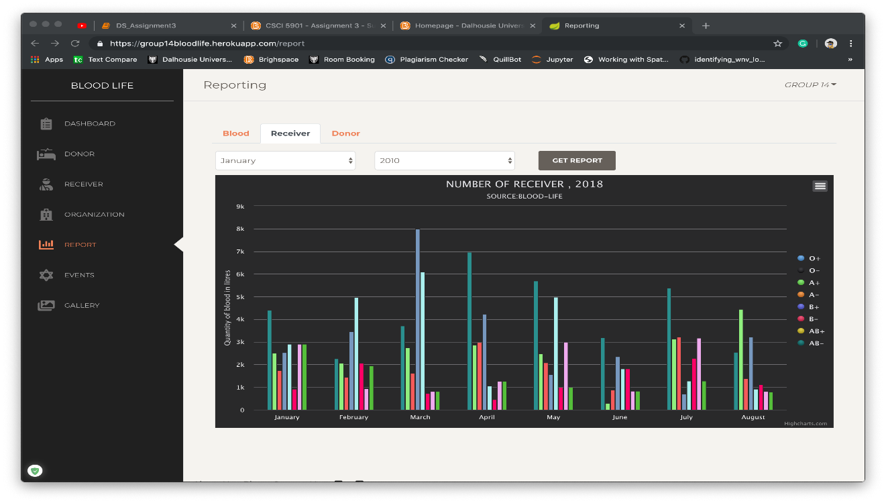

Figure 36) Organization Report

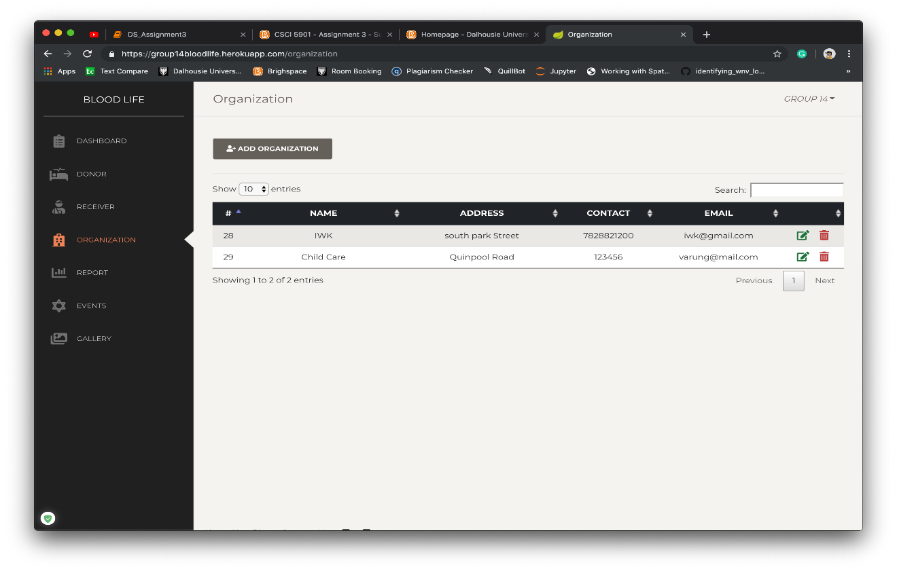

Figure 37) Organization Registration confirmation

### INVENTORY

**Client-side:** The project will use Java Server Pages (JSP) for building the front-end User Interface. JSP uses a combination of HTML, CSS, JavaScript, jQuery and Java to build a web-page. To polish the user interface Bootstrap is used. Bootstrap is the most used HTML, CSS and JavaScript framework is used to create responsive (ability to adjust to different screen sizes) webpages. The webpages have multiple images that have been taken from multiple sources like unsplash.com, all the references of the used images have been added to the README file in the git repository of the project.

**Server-side:** The project will use Spring-boot framework. Spring-boot is Java based framework. Java has simple yet powerful support for threading and concurrency control. It is portable and runs on a lot of devices. Spring-boot provides excellent performance and security with microservices. It is a powerful framework which can handle excessive request without compromising with performance. Spring boot comes with embedded tomcat server. There are lot of production ready functionalities this framework provides. Considering this project, the project is large and highly scalable project. Therefore, we decided to use spring-boot framework as a server-side technology for our project.

# Application Workflow

## Interaction design

### Click Streams

This section covers the clickstream for the opted features.

Figure 38 shows the clickstream for searching for organization on BloodLife.

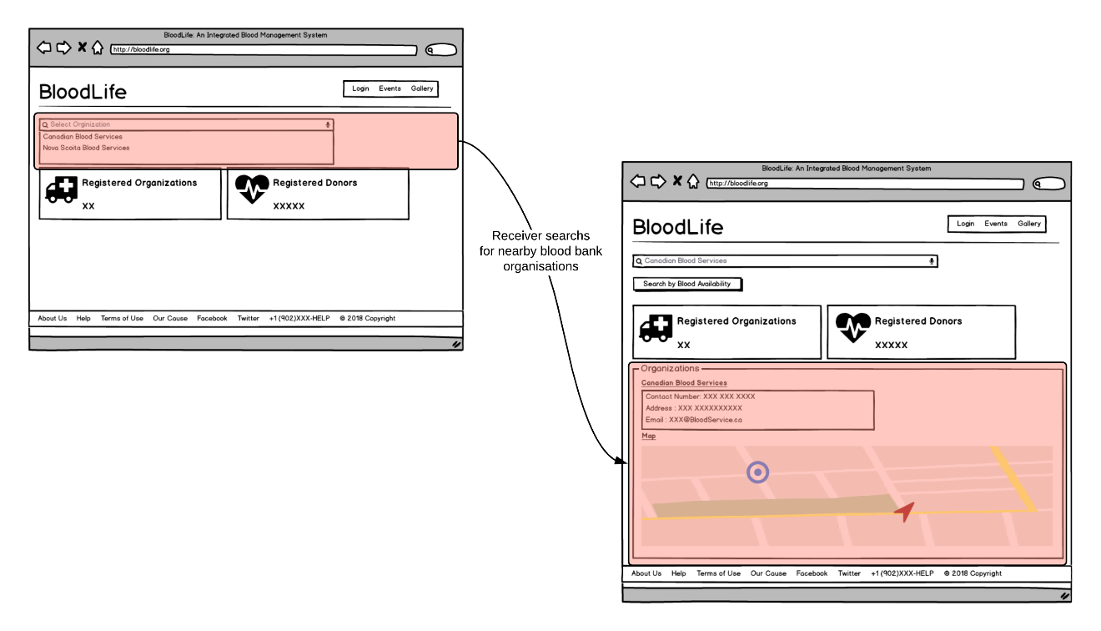

**Figure 38) Search Organization[11][15]**

Figure 39 shows the clickstream for Gallery Page section on BloodLife.

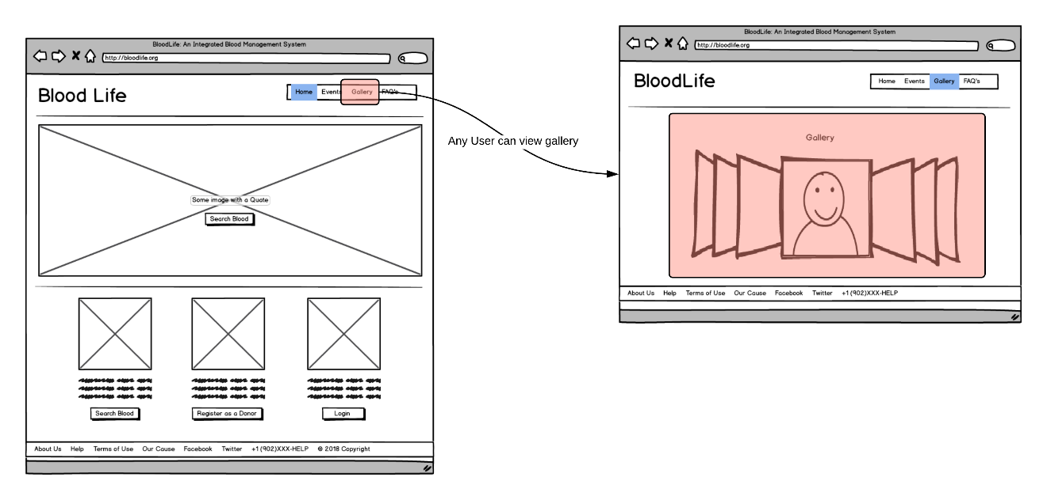

**Figure 39) Gallery Page[14][15]**

Figure 40 shows the clickstream for searching donors in BloodLife.

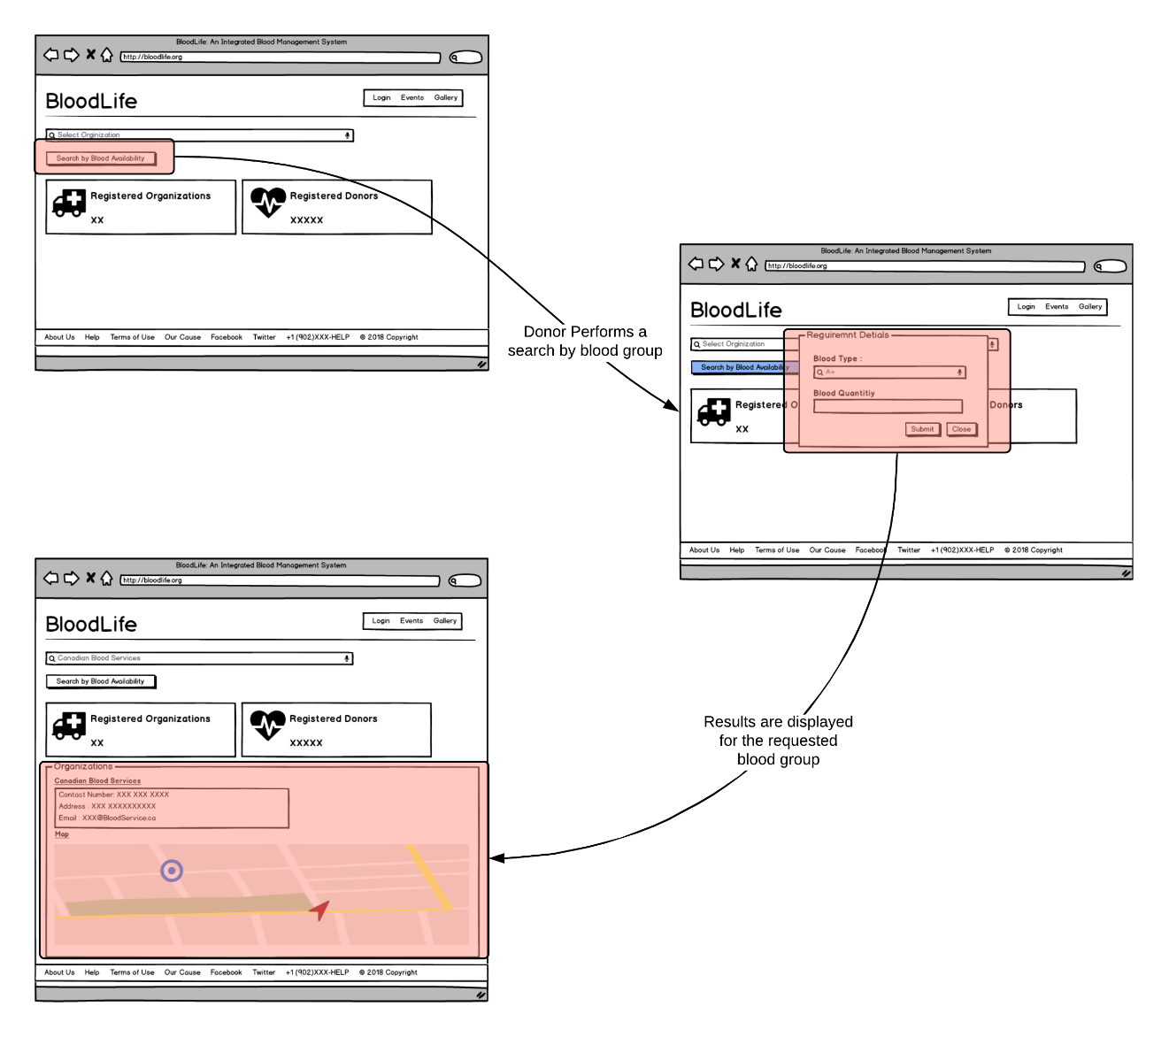

**Figure 40) Search Donor[11][15]**

Figure 41 shows the clickstream for Event Display section on BloodLife.

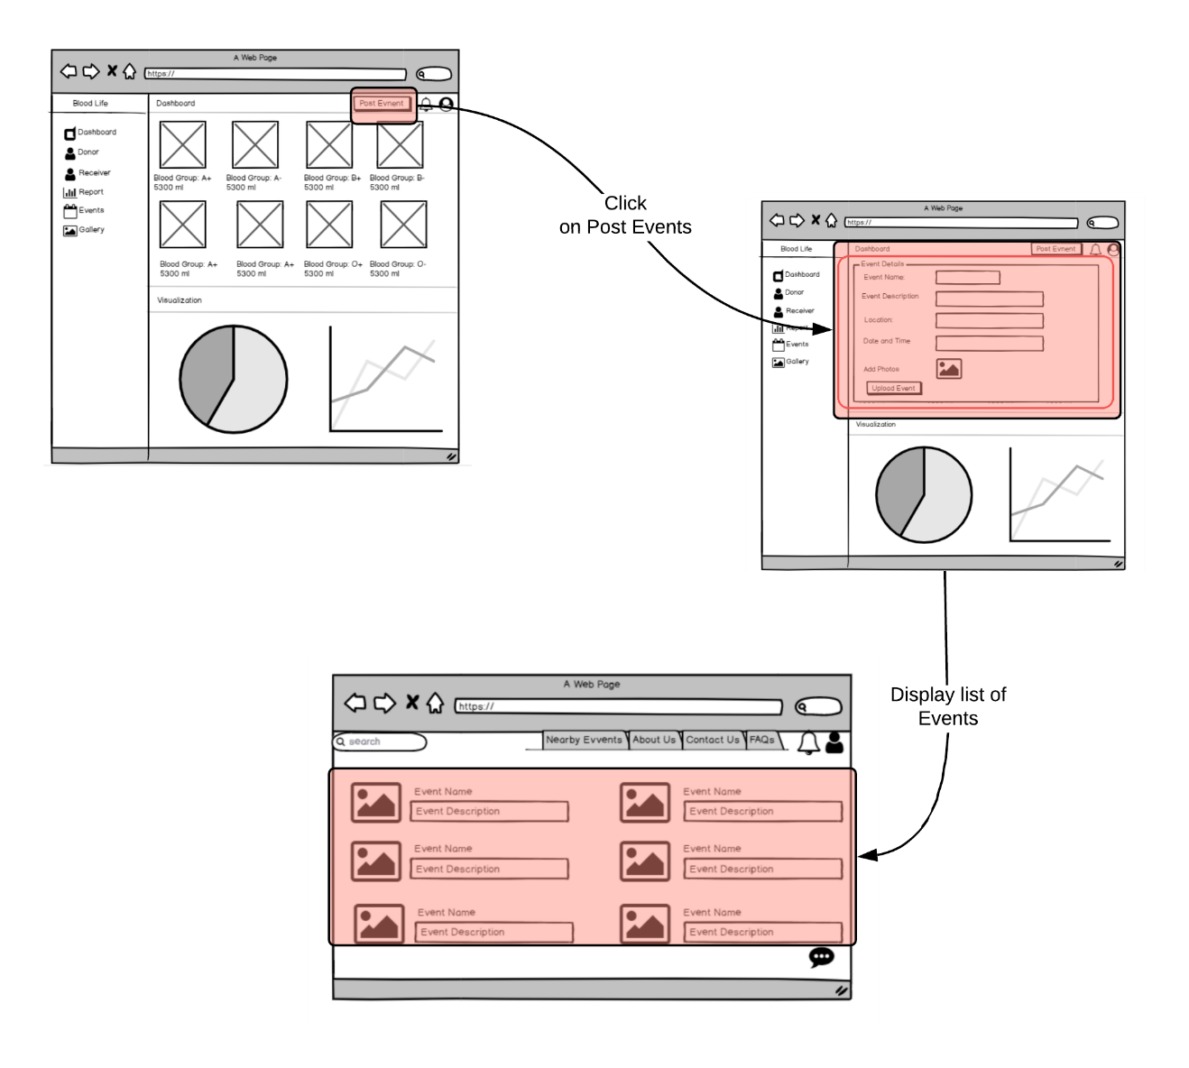

**Figure 41) Events Display[12][15]**

Figure 42 shows the clickstream for Monitoring System in BloodLife.

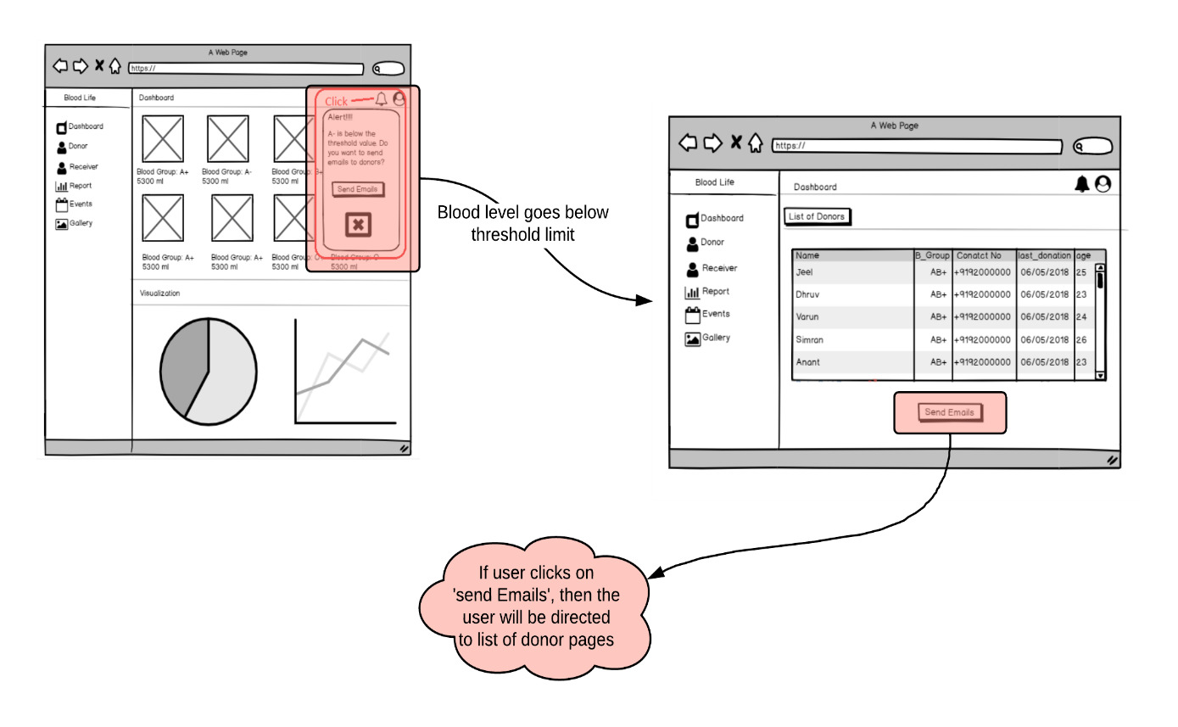

**Figure 42) Monitoring System[12][15]**

Figure 43 shows the clickstreams through which the organization user can view reports on BloodLife.

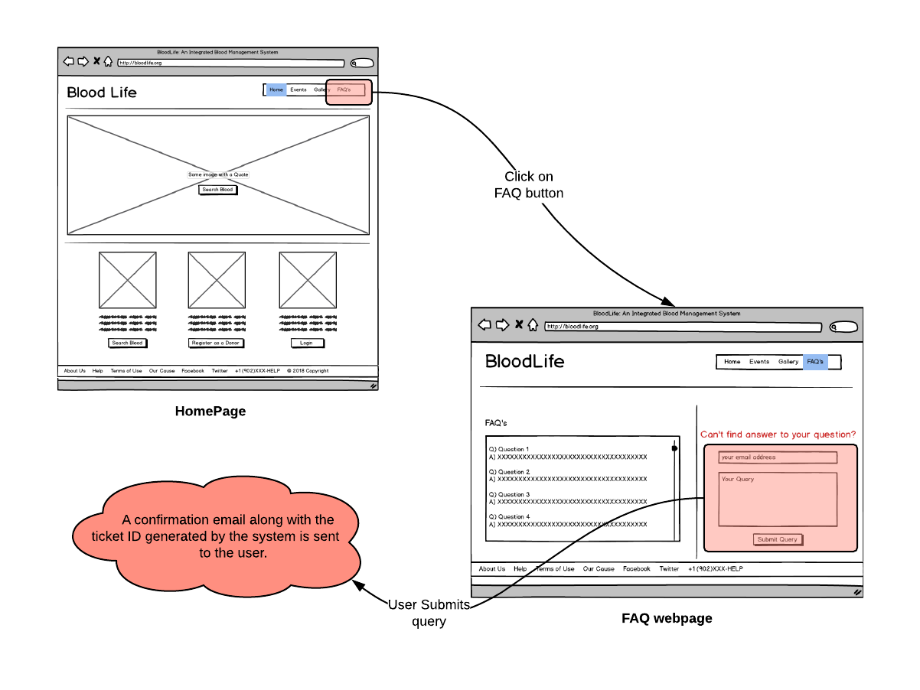

**Figure 43) Report Collection[10][15]**

Figure 44 shows the clickstream for Frequently Asked Question (FAQ’s) section on BloodLife.



**Figure 44) FAQs[10][15]**

Figure 45 shows the clickstream for organization dashboard on BloodLife.

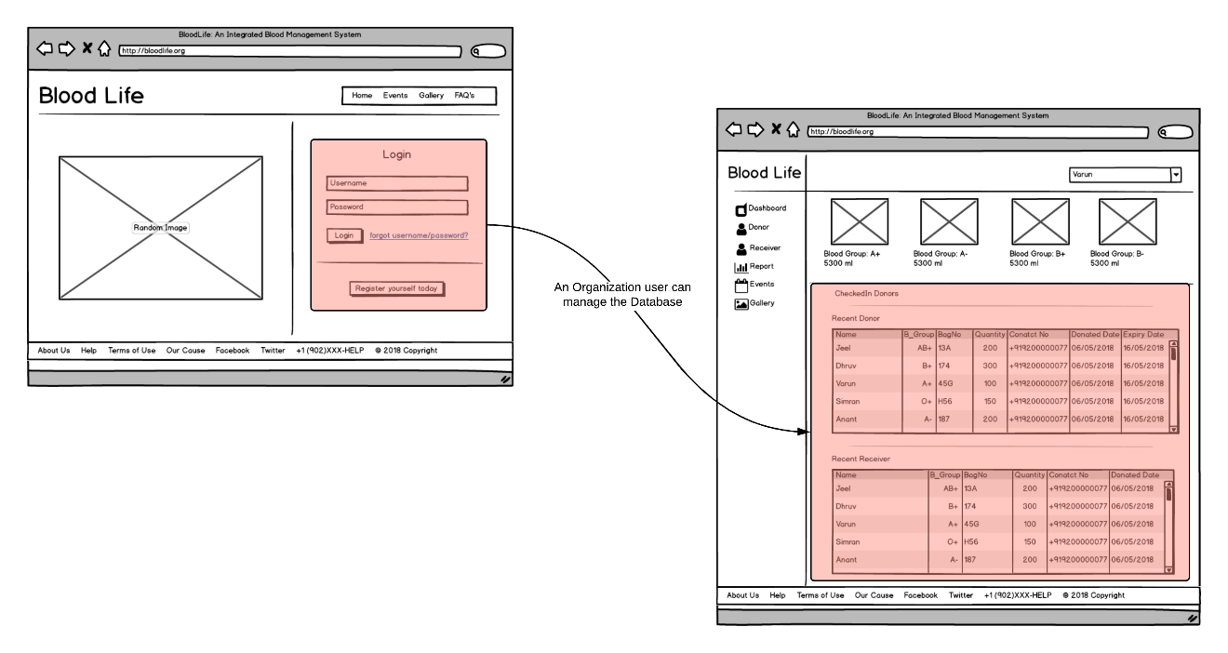

**Figure 45) Organization Dashboard[14][15]**

Figure 46 shows the clickstream for Login Page on BloodLife.

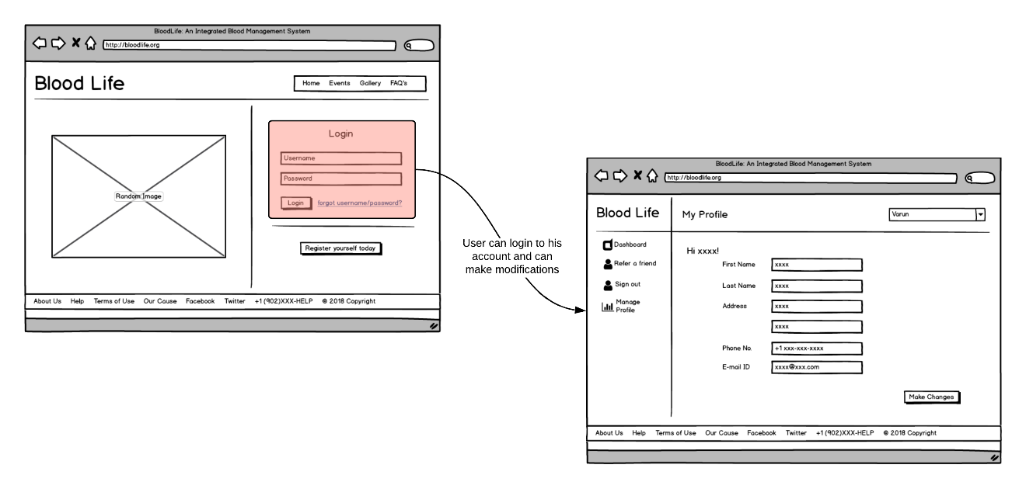

**Figure 46) Login Page[13][15]**

## Process and Service Workflow

### Workflow of The Application

Given below is a brief description of the workflow of BloodLife:

* Blood Bank organizations are registered with BloodLife and once registered they are provided with an administrative account where they can **maintain records of various blood group units available at site, historical records of blood given to a seeker or blood collected from a donor etc.**
* **A person who wishes to donate blood takes the user persona of donor and can register with BloodLife. Once registered, the users are provided with a donor account and they can manage the account and refer their friends on BloodLife.**
* **Users who are in need of blood, i.e. receivers, do not have to register themselves with BloodLife. They can simply search the web portal by entering the blood group type.**
* **The results of the desired blood group are then fetched from various blood bank organizations and** are displayed based on the distance from user’s location.
* The receiver can then go to the nearest blood bank organization that has the desired blood group using the navigation feature on web application.
* Whenever the count of a blood group unit goes below the pre-define threshold value, an alarm is raised to the organization and an email/SMS notification is sent to all the donors of the specific blood group type.

This way, blood bank organizations can ensure that they are always stocked up.

* Further, the blood bank organizations are provided with a feature to fetch weekly, monthly or quarterly reports regarding the blood samples donated, availability of different blood group units etc.
* In case of a query, the users can visit the FAQ & Feedback page to get answers to their queries. If they are not satisfied by the answer on the webpage, they have an option to raise a ticket on BloodLife. There query will be sent to the respective blood bank organization and the users will be notified via email whenever their query is answered.

### Technology Used

In order to display reports, we can either run SQL queries on database or opt for an Object Relational Mapping (ORM) tool such as Hibernate [6] Framework that tends to simplify the development of Java application to interact with the database.

In our case, we will be using Hibernate Framework to execute SQL queries on the database. The primary reason for using Hibernate framework is that it performs faster on large Databases. Also, fetching data from several tables is easy in hibernate framework.

Further, on getting the required information from the database we will plot interactive and responsive charts to create the reports. We will use Highcharts [7] for plotting of these charts. Highcharts is a SVG based JavaScript charting library that provides an easy way to add interactive charts to a website. It makes it simple for web and mobile projects to add interactive, mobile-optimized charts.

### File and Folder Structure

Figure 6 describes the folder structure that we will be using for our project which has been borrowed from Spring boot.

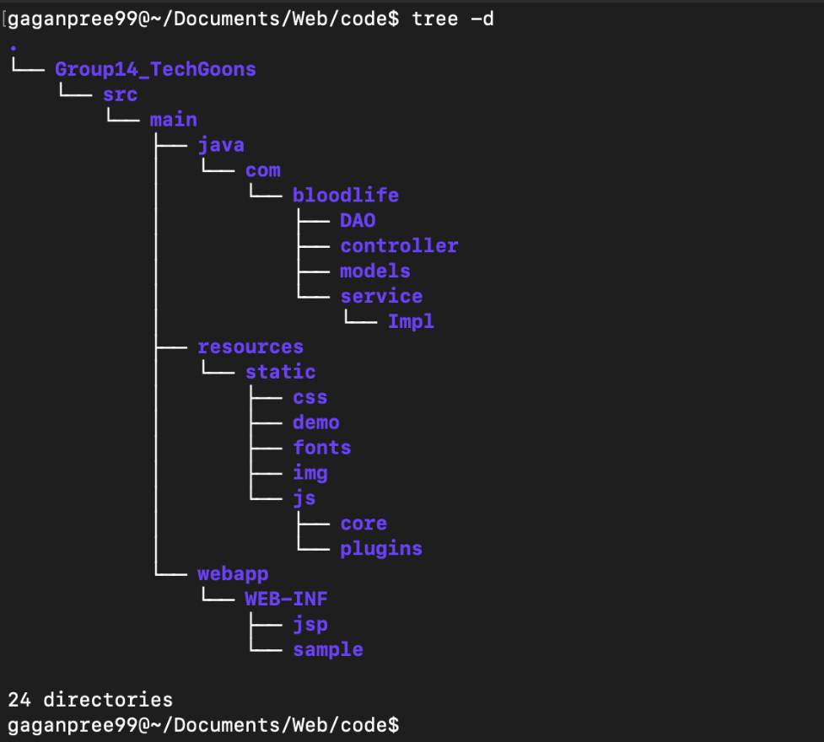

**Figure 47) File and Folder Structure[2][10]**

# GROUP ROLES

The following roles have been assigned to the team members:

|  |  |  |  |
| --- | --- | --- | --- |
| **Serial No.** | **Group Member** | **Primary Role** | **Secondary Role** |
| 1. | Dhruv Purohit | Lead Developer (Back-end) | W3C guidelines Validator |
| 2. | Gaganpreet Singh | Lead Designer | Document Manager |
| 3. | Ghazayil Alkhalifah | Lead Designer | Database Manager |
| 4. | Jeel Gondaliya | Lead Developer (Front-end) | Tester |
| 5. | Mohammed Sohail Ahmed | Lead Developer (Full Stack) | Tester |
| 6. | Varun Mahagaokar | Lead Developer (Full Stack) | GitLab Maintainer |

This distribution ensures that each team member contributes equally in the project.

# REFERENCES

1. Mwangi, P. K. (2017). Prototype for tracking voluntary blood donors in enhancing emergency medical response: case Aga Khan Hospital (Thesis). Strathmore University. Retrieved from <http://suplus.strathmore.edu/handle/11071/5679>
2. Lucidchart.com, 2019. [Online]. Available: <https://www.lucidchart.com>.
3. Balsamiq.com, 2019. [Online]. Available [https://balsamiq.com](https://balsamiq.com/)
4. “Spring Projects", Spring.io, 2019. [Online]. Available: <https://spring.io/projects/spring-boot>
5. "Why Spring Boot is an Excellent Choice for Your Next Applications", Hacker Noon, 2019. [Online]. Available: <https://hackernoon.com/why-spring-boot-is-an-excellent-choice-for-your-next-applications-cf5a0cdfa04f>
6. How Much Blood Is in the Human Body? (2019). Retrieved from <https://www.healthline.com/health/how-much-blood-in-human-body>
7. Content taken from Assignment 1 submission of CSCI 5709 by Gaganpreet Singh (Banner ID: B00819217)
8. Content taken from Assignment 1 submission of CSCI 5709 by Ghazayil Alkhalifah (Banner ID: B00559684)
9. Content taken from Assignment 3 submission of CSCI 5709 by Dhruv Purohit (Banner ID: B00821734)
10. Content taken from Assignment 3 submission of CSCI 5709 by **Gaganpreet Singh** (Banner ID: B00819217)
11. Content taken from Assignment 3 submission of CSCI 5709 by **Ghazayil Alkhalifah** (Banner ID: B00559684)
12. Content taken from Assignment 3 submission of CSCI 5709 by **Jeel Gondaliya** (Banner ID: B00819827)
13. Content taken from Assignment 3 submission of CSCI 5709 by **Md. Sohail Ahmed** (Banner ID: B00821054)
14. Content taken from Assignment 3 submission of CSCI 5709 by **Varun Mahagaokar** (Banner ID: B00826634)
15. Lucidchart.com, 2019. [Online]. Available: https://www.lucidchart.com.